Al-Nahda Scientific Journal  The Open University of Sebha | 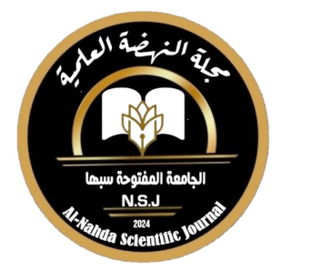 | مجلة النهضة العلمية  الجامعة المفتوحة سبها
Declaration and Pledge
I, the undersigned (principal researcher - co-researcher), declare that my research entitled ..............................................................................................................................................................................................
1. The research was prepared by me, in an objective and scientific manner, and I am prepared to bear full legal responsibility if it is proven that the research was plagiarized from the efforts of another researcher.
2. I also declare that the research has not been previously published, in print or electronically, and is not submitted for publication to another party, and has not been previously refereed by One of the scientific journals, inside or outside Libya.
3. I also grant the electronic publishing rights for my research to Al-Nahda Scientific Journal without any conditions or restrictions.
4. I also pledge that the research or parts of it will not be published elsewhere after its publication in Al-Nahda Scientific Journal is approved, except after obtaining written permission from the Editor-in-Chief.
5. I also pledge to take into account the comments of the referees and the journal's editorial board, and that I have reviewed the publishing rules in Al-Nahda Scientific Journal of the Open University. Sebha.

Name: .....................................................................................................
Academic Title……………………………………………………………………………….............
Specialization of Research……………………………………………………………… ..........
Postal Address…………………………………………………………………………………. .....
Email………………………………………………………………………………………………… ....
Phone………………………………………………………………………………………………. .....
Employer………………………………………………………………………………………….. .....
Date……………………………………………… ...Signature: .....................................

